Git Challenges-02
1. Resolve Merge Conflicts
- Create a merge conflict intentionally (two users editing the same line).
- Resolve the conflict and push the changes.

When tried to merge branches came up with error Automatic merge failed
Resolved the conflict and pushed the changes
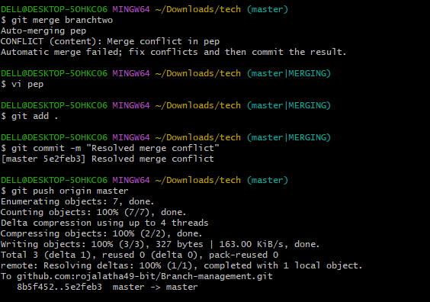
Using command git log --oneline –graph was able to see a merge commit in the history.

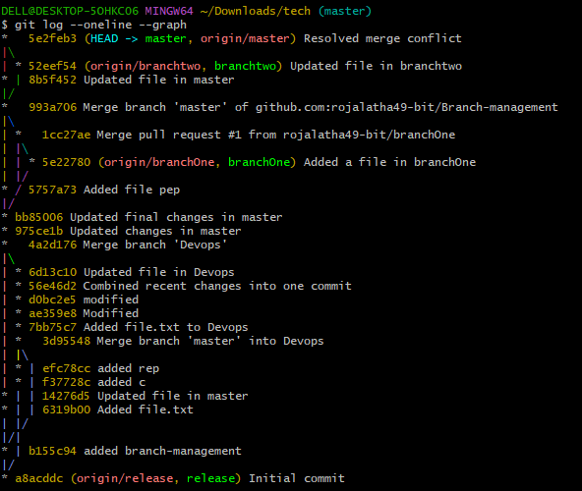
2. Recover Deleted Branch.
- Delete a local branch and then recover it using the reflog..
Deleted branch using git branch –D branchtwo
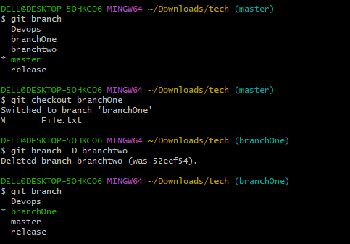
Viewed reflog using git reflog

Recovered the deleted branch and switched to that branch
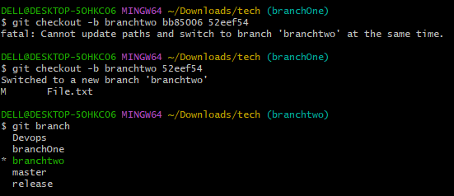

3. Undo Wrong Push.
- Push a wrong commit to GitHub, then undo it without losing history.
Pulled commit using git log –oneline and see that f37728c is my wrong push/pushed by mistake

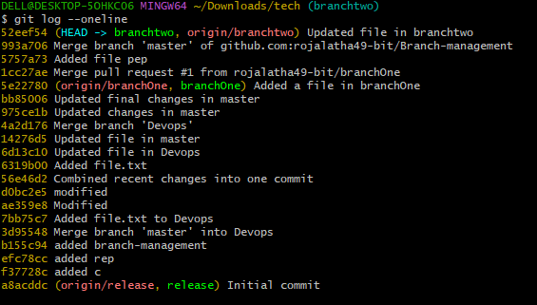
Reverted the push using command git revert commit id
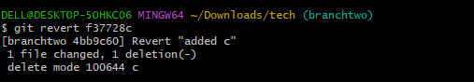
4. Amend a Commit.
- Make a commit, then add a missing file to it using git commit --amend..

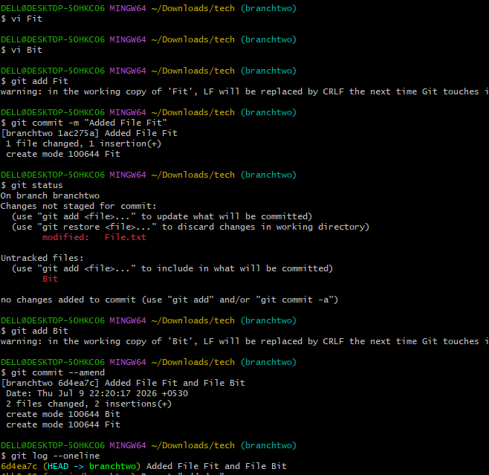
5. Cherry-pick a Commit.
- Take a specific commit from one branch and apply it to another branch..

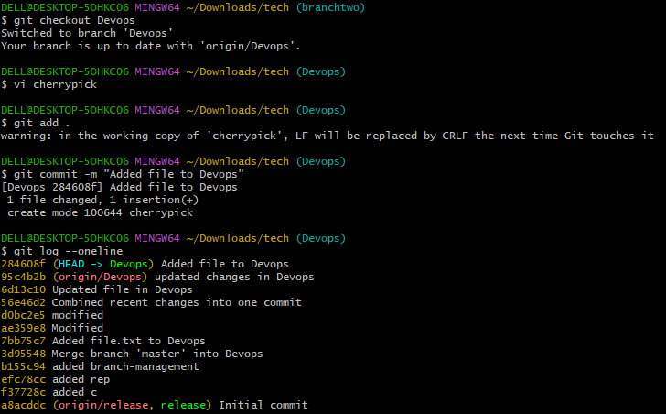
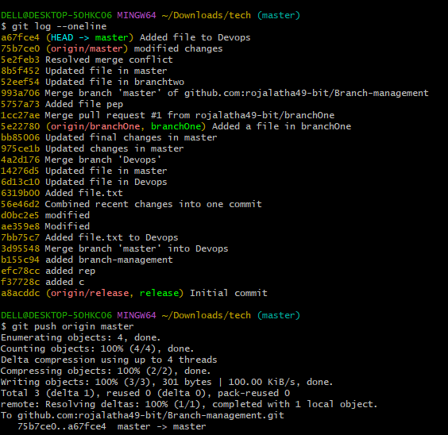

6. Interactive Rebase.
- Reorder and squash multiple commits into a single clean commit..
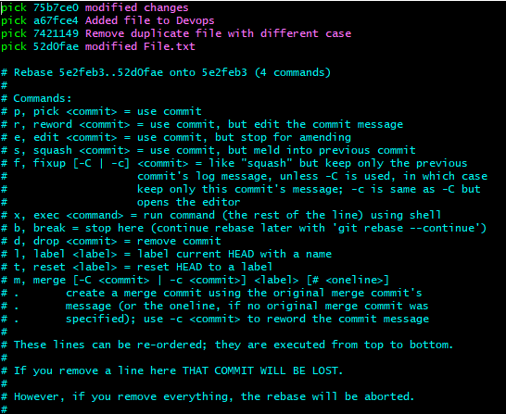
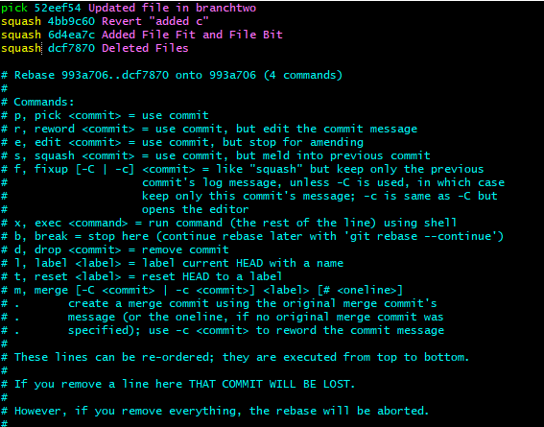

7. Tagging & Release.
- Create a version tag (v1.0), push it to GitHub, then delete and restore it..
Created a version Tag v1.0 and pushed it to Github.
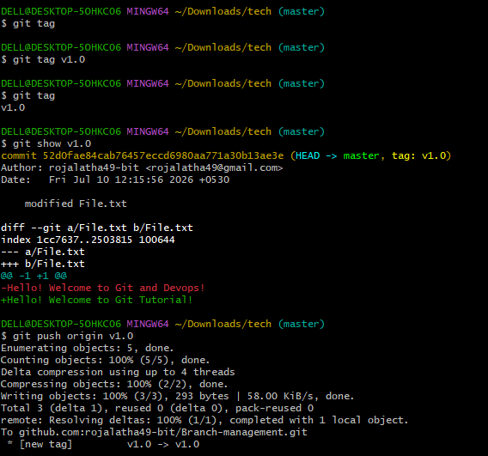
Deleted the tag, restored it and pushed to github.
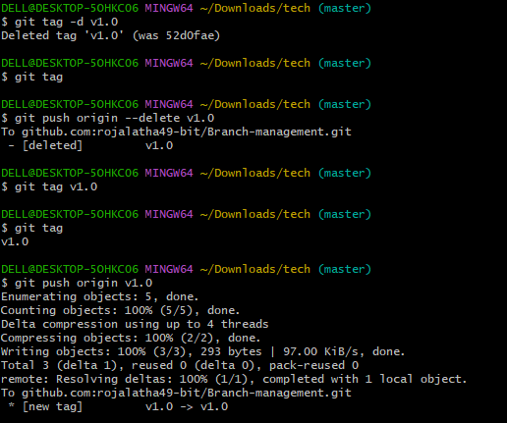
8. Clone with Sparse Checkout.
- Clone only a subdirectory of a repo using sparse checkout..
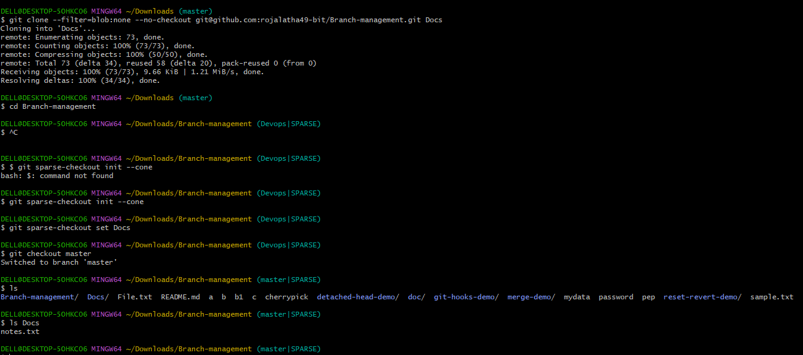
9. Reset vs Revert Challenge.
- Demonstrate the difference between git reset –hard and git revert in a repo..
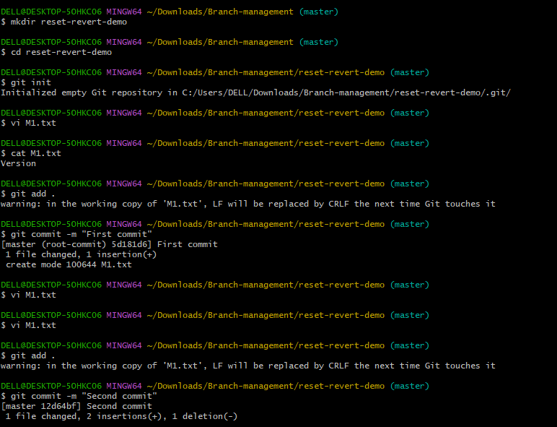

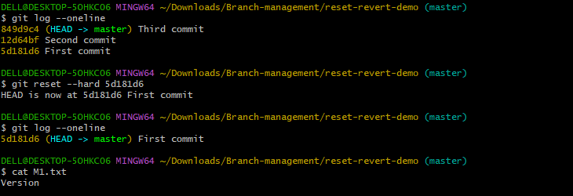

10. Detached HEAD Challenge.
- Checkout a specific commit (detached HEAD state) and create a new branch from it..
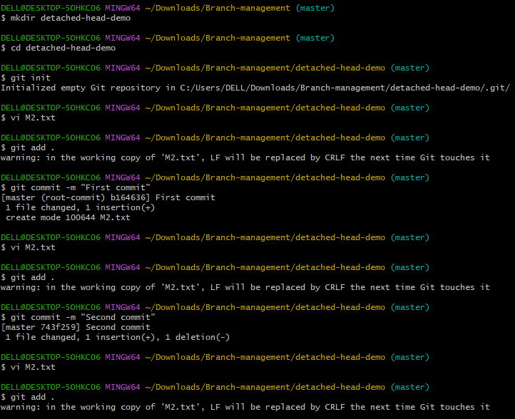

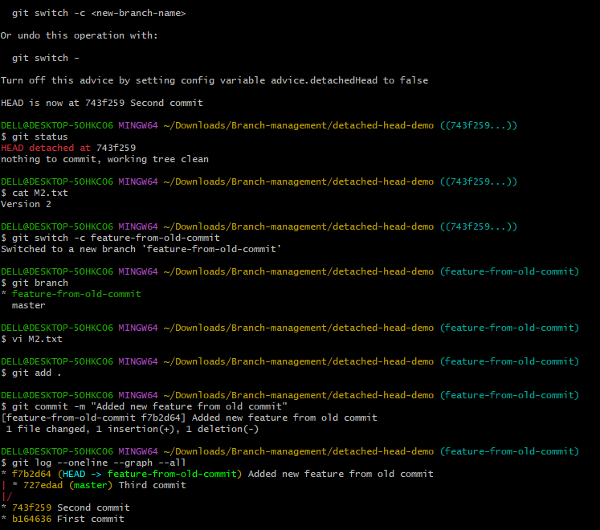
11. Git Hooks Challenge.
- Configure apre-commithook to reject commits without a message format (e.g., must start withJIRA-XXX)..
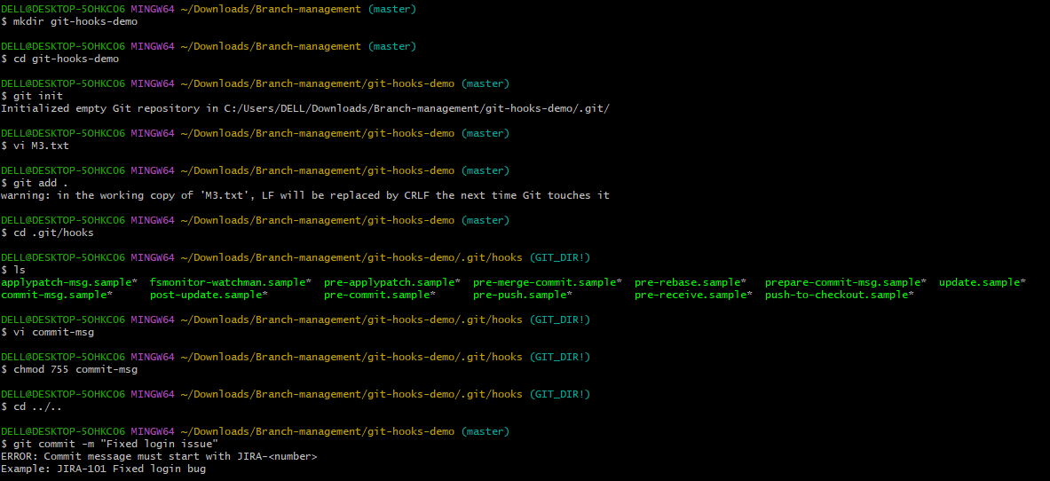
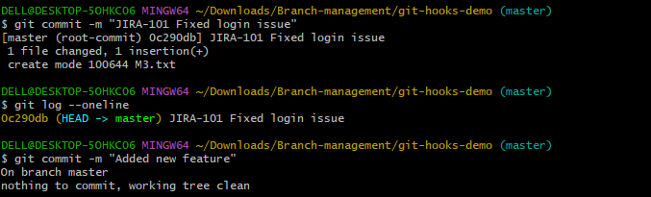
12. Squash Merge vs Rebase Merge.
- Show the difference between squash merge and rebase merge with evidence..
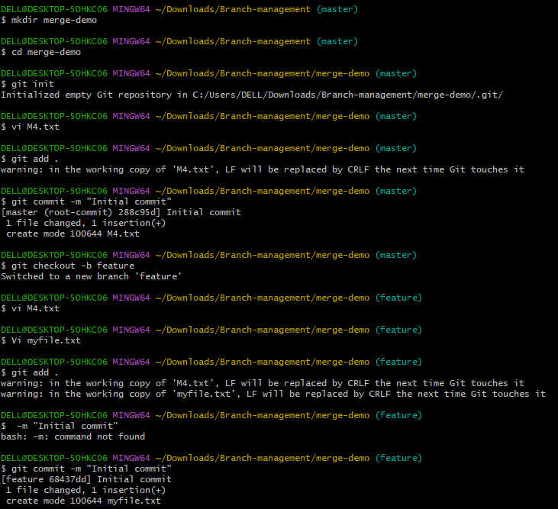
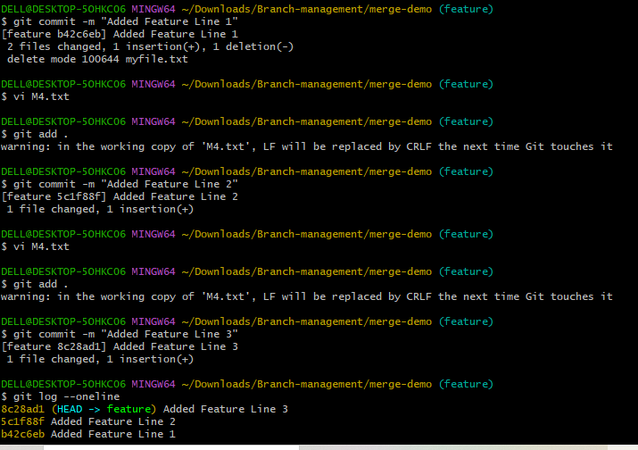

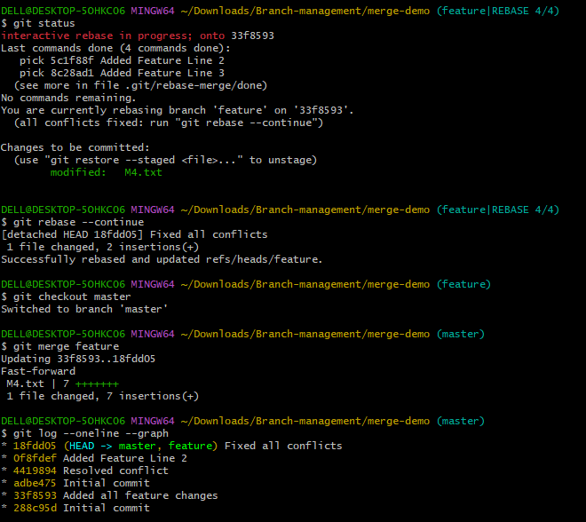

13. Fork & Pull Request Workflow.
- Fork a repo, make a change, and submit a pull request to the original repo..
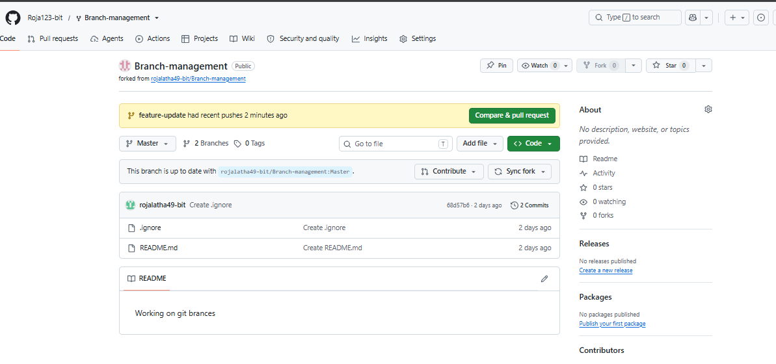

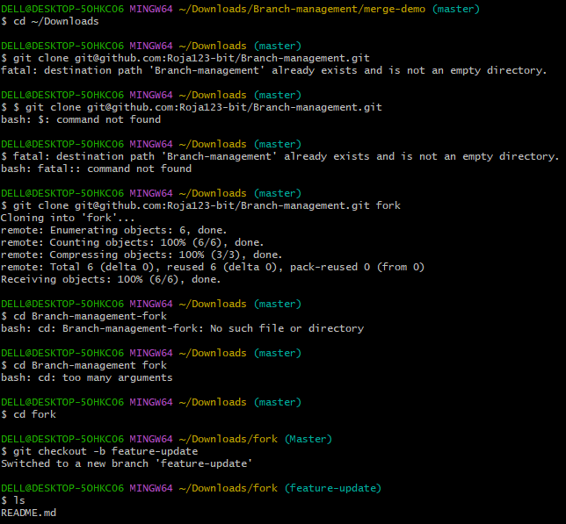
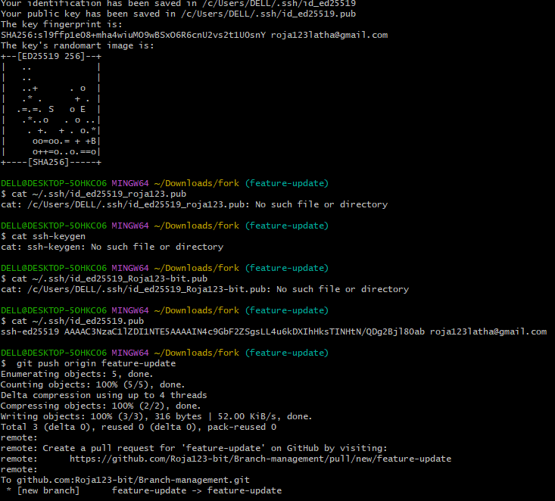
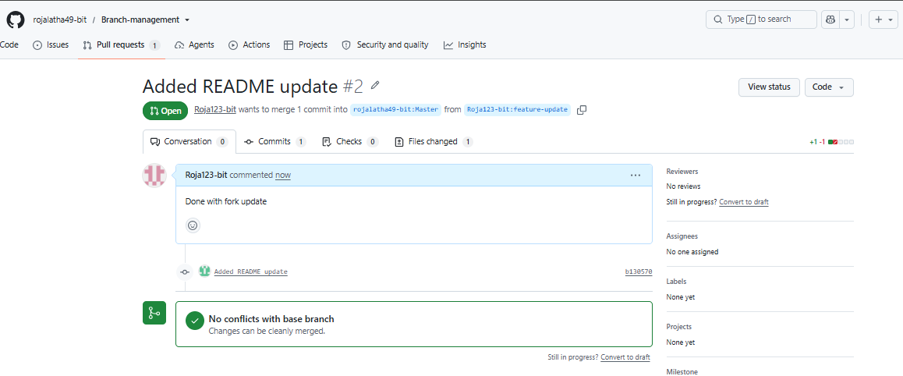

14. Recover Lost Commit.
- Commit something, reset hard, and then recover it using git reflog..
